Welcome!
Date
Name
Spouse
Address
City
State Zip _________
Email

Please Contact By
❑ Card  Phone  Visit

Telephone Best Time to Call
Home ______________
Work ______________

Guest: First Time Second Time
Are you a church member: yes no
Church
City, State

Circle Appropriate Age/Grade Group(s)
Preschool: Ages: B-1 2-3 4-5
Children: Grades: K 1 2 3 4 5 6
Youth: Grades: 7 8 9 10 11 12
Adults: Ages:18-29 30s 40s 50s 60s+

How did you learn about our church?
Newspaper Friend Yellow Pages Mail
Other

I am a guest of:

New in the Community? Yes No
Names & ages of children at home

Weekly Service & Activity Schedule

May 4, 2014
9:45 a.m. Sunday School
10:45 am Homecoming Worship Service
Dinner on the Grounds

Week of May 5 – 10
Wednesday, 6:30 p.m. Youth Activities
Wednesday, 6:45 p.m. Adult Prayer & Bible Study
Thursday, 10 a.m. Adult Fellowship


Upcoming Events
May
4 Homecoming
4 Kids in Action
8 Adult Fellowship – 10 am
11 Mother’s Day
11 Texas Baptist Hunger Offering
18 Assoc Music Festival – Chappell Hill – 6 pm
22 Adult Fellowship – 10 am
25 Birthdays and Anniversaries
26 Memorial Day

Birthday & Anniversary Recognitions will occur on the final Sunday of each month.

Knobbs Springs Baptist Church

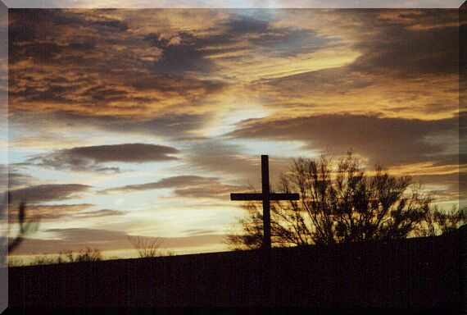

HOMECOMING

Jesus did not let him, but said, “Go home
to your own people and tell them how much the Lord has done
for you, and how he has had mercy on you.”
Mark 5:19

May 4, 2014

Church Information:
KnobbsSpringsBC.com KnobbsSpringsBaptist@gmail.com
1662 CR 305, McDade, Texas 78650 512-273-2743
Brother Dwight Reagan 512-247-6448
Kimberly Tabor, Office Manager 512-698-2804

